**Observations**

* Implementing Availability, Fault Tolerance and Elasticity in our local data centers with limited budgets or resources is difficult to implement.
* So there exists a need where you get your infrastructural needs / application needs delivered as a Service (Similar to Electricity)

**Terms**

* Cloud Provider:
  + Is an Orgnaization that provides Cloud-Based IT resources.
  + Examples: Amazon, Microsoft, Google
* Cloud Consumer:
  + Is an Organization that has a formal contract/arrangement with Cloud Provider to use IT resources provided

**Cloud Delivery Models**

* To deliver the Cloud Based Services to the Cloud Consumers, there are three popular models 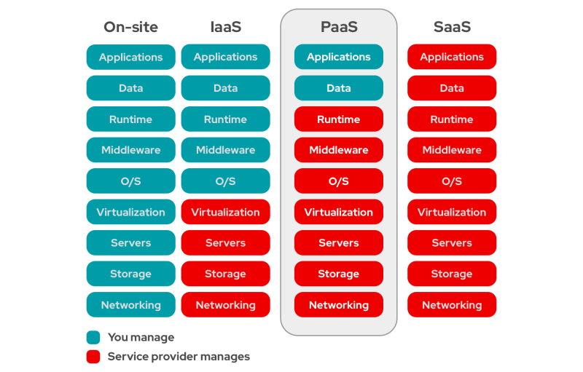
  + Infrastructure As A Service (IAAS)
    - Infrastructure from you
    - Needs from the customer will be RAW IT (Virtual Machine, Disk, Network Disk, Networking)
    - Once virtual infrastructure is created the cloud consumer will be the owner of resource and billing might start (depends on payment mode)
  + Platform As A Service (PAAS)
  + Software As A Service (SAAS)

**Cloud Provider Infrastructure**

* Will have data centers with lot of racks which in turn have lot of servers, Providers use these servers to provide IT Resources to the Consumers
* Cloud Providers provide the Services in two possible models
  + Single-tenant 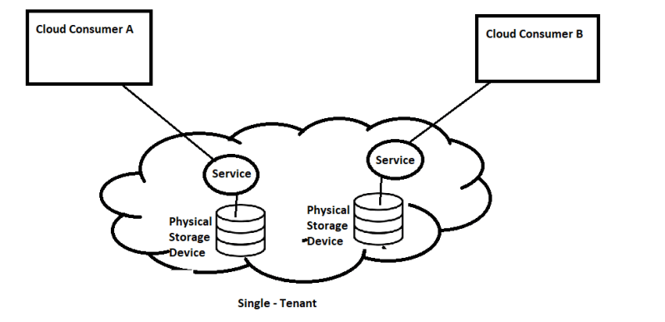
  + Multi-tenant 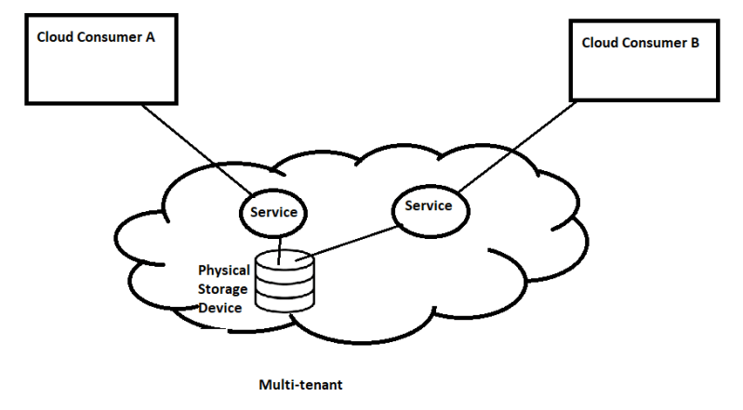
* Multi-tenant is generally cheaper because cloud providers can effectively use their hardware’s

